# **Malware Analysis Report: SMB.exe/SMB.dll**

## **Overview**

This report provides an analysis of a suspected malware sample. The first section covers included DLLs. DLLs are not typically executed in a linear or sequential manner; instead, they expose callable functions and classes that may be invoked by an external process in a non-linear, event-driven, or conditional fashion. Accordingly, this analysis focuses on **logically significant components** of the DLL, rather than attempting a start-to-finish execution trace.

All DLL files in this sample are .NET assemblies developed in C#.

**Note:** For security reasons, code excerpts have been reduced to **syntaxless pseudocode**, and certain portions of the code have been redacted.

**UPDATE AS OF 8/17/25: THIS MALWARE SAMPLE IS NOW INERT! THE C2 DOMAIN HAS BEEN TAKEN DOWN AFTER MY REPORTS, RENDERING THE MALICIOUS SECTIONS OF CODE INERT**

## **Namespace 1: DnsResolver.Services**

### **Class: Utils**

| **Function** | **Description** |
| --- | --- |
| GetHostName() | Returns the local machine's hostname. |
| GetDomainName() | Queries Win32_ComputerSystem via WMI to determine if the device is domain-joined; returns the domain name or a status message. |
| GetLocalIPAddresses() | Returns a list of all local IPv4 addresses on the system as strings. |
| createTaskId(ip) | Generates a numeric ID from an IP address by summing its octets (e.g., 192.168.0.10 → 370). |

**Notes:**

* All methods in this namespace are callable from any external process.

## **Namespace 2: SMB**

Code is heavily redacted for security purposes.

### **Key Functionality**

#### **Agent ID Management**

FUNCTION getAgentId()

IF AgentId is null THEN

IF file at agentIdFilePath exists THEN

READ contents of file

SET AgentId = file contents

ELSE

GENERATE new 5-character ID using IdGenerator

SET AgentId = generated ID

WRITE AgentId to agentIdFilePath

END IF

END IF

RETURN AgentId

* agentIdFilePath = cfg.dll
* cfg.dll stores a 5-character ASCII string generated by IdGenerator.
* **Agent ID role:** Critical for victim authentication to the C2 server. A new ID is only generated if the file is missing. Modifying the file does **not** trigger a new ID.

#### **Victim Authentication Flow**

IF HttpHelper.Get(Http.BaseURL + "register/?s=1", "token", getAgentId()) == "ok"

RETURN true

ELSE

RETURN false

* Http.BaseURL points to the C2 beacon (defanged: hxxp://api.fastrdp.online/api/).

#### **Additional Functionality**

* Remote command execution via headless PowerShell.
* Reports system uptime to C2.

## **Dynamic Analysis Findings**

* Conditional logic appears to filter based on:  
  + Domain membership.
  + Device uptime
  + Hardware specifications (CPU, RAM).
* Confirms client authentication workflow and C2 registration.
* Remote command execution is confirmed to be possible; may serve as a dropper.
* Exfiltration occurs upon program launch:  
  + Heartbeat sent to API over HTTP.
  + Data is sent to C2 and appears fragmented and encrypted across TCP segments.
* Reads a wide array of registry keys.
* All program modules have **timestomped metadata**.
* Modifies onedrive files, unable to analyze further due to sample being inert (spoken of earlier in paper).
* Observed C2 endpoint IPv4 address: 64.44.154.197 (hosted by Nexeon Technologies as of 08/06/25).
* Tasks added to task scheduler relating to onedrive, confirmed unrelated to normal operating system functions.

## **Summary**

The SMB-release sample exhibits standard malware behaviors:

* Victim authentication and fingerprinting.
* Remote command execution and dropper capabilities via headless powershell.
* Data exfiltration over encrypted TCP, possibly living off the land with bcrypt.
* Anti-forensic techniques such as timestomping of process modules.
* Environmental awareness through checks for domain membership, possibly virtualization, uptime, Win Defender configuration, and hardware specs.
* Possible persistence with task scheduler and onedrive (undetermined, now inert)

This analysis provides both static and dynamic insights into the sample, highlighting its C2 communications.

## **Removal and Mitigation**

The following section contains information related to the removal of the malware from an affected machine.

* After discovery of compromise by this malware, the infected machine should be **IMMEDIATELY** disconnected from all networks.
* Full disk format/secure erase all disks connected to the infected device, re-install operating system from a trusted source. **DO NOT DO AN IN PLACE UPGRADE/REINSTALL.**
* If other removal tips can not be done, modify the hosts file so that any DNS queries for the malware’s C2 domain resolve to an inert address.
* If the C2 domain is no longer registered/active, the malicious code will not execute successfully. (no longer registered as of 8/17/25)

## 

## 

## 

## 

## 

## 

## 

## 

## **Images**

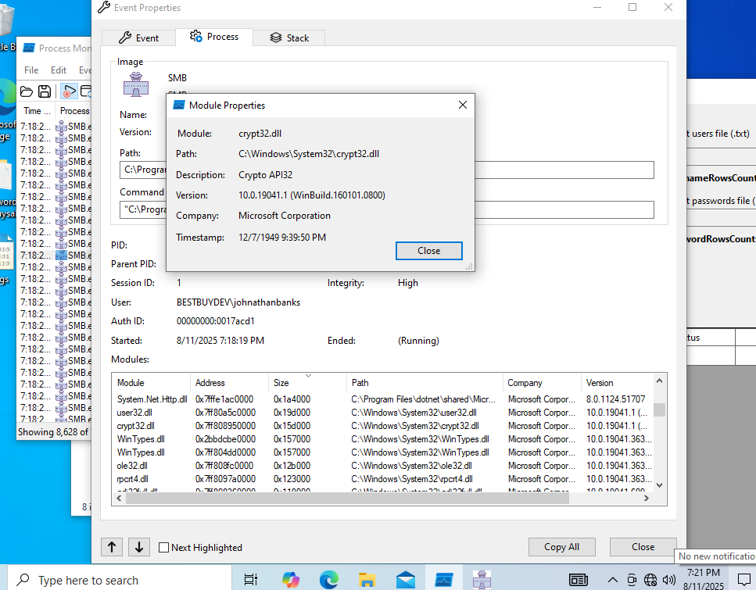

*Timestomping*

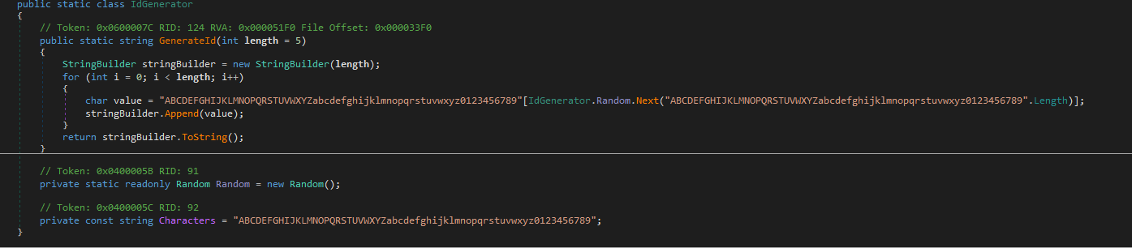

*Agentid generation snippet*

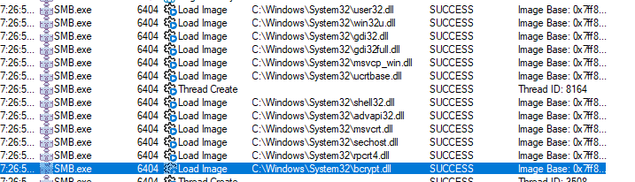

*Use of bcrypt.dll and other important .dll files*

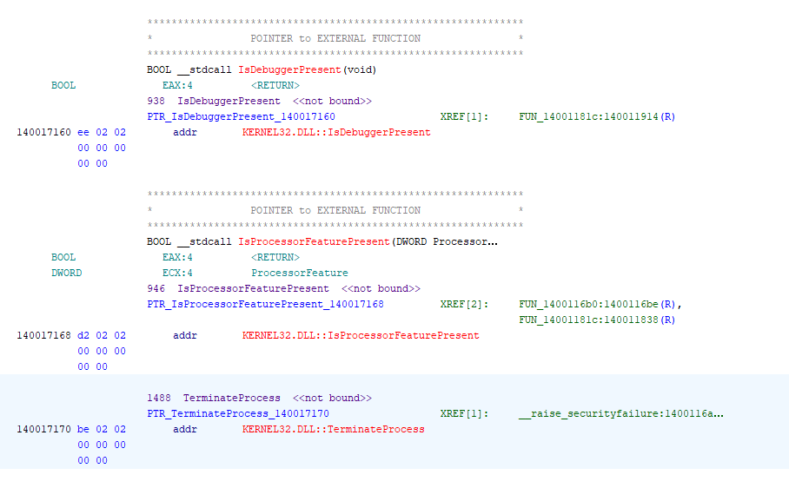

*Anti debugging instructions*

**Hashes**

* SHA256 9B9689ADEF78ADF5AEA081699F229F5189DD90BDA174348DF5BF6FB36B91F852 (fastSMB.zip)
* SHA256 EF9E28020A5111E96A51BA41590D6F7586E639108CDD18262548216C0F605B9E (smb.dll)
* SHA256 48A2F1A71ED64B59625AF67C404EBB7414C5B095A3AACB45E9B962342C211FAA (smb.exe)